Text chunking strategies
Chunking is the process of dividing long text into shorter sections known as “chunks”, which improves the efficiency of vector searches, embeddings and other retrieval techniques. A full manual content cannot be read by Large Language Models (LLP) in a single sitting. In this sense, chunking will enhance both the LLM’s accuracy and performance.

Why is chunking needed?
Chunking is important for AI because it divides large datasets into manageable chunks that helps the LLM’s overcome context window limitations, increase the processing efficiency, improve the retrieval accuracy, lowering the computational cost and also help the models concentrate on useful semantic meaning for better, clearer AI outputs.
Key reasons for chunking in AI
- Overcomes LLM context limits by splitting long documents into smaller chunks that fit within token boundaries.
- Improves retrieval accuracy in RAG by helping the system find the right information and reduce hallucinations.
- Boosts processing efficiency because smaller chunks are quicker and cheaper to embed, store and search.
- Preserves context and meaning through strategic chunking rather that random splits.
- Optimizes embedding quality while balancing precision and thematic understanding
- Supports scalability, allowing the AI systems to handle increasing data volumes without performance issues.
Common chunking methods
Using techniques like Fixed-Size (by tokens/chars), Sentence/Paragraph-Based, Sliding Window (with overlap), Recursive Chunking (hierarchical separators), advanced Semantic Chunking (by topic/meaning) or Agentic Chunking (AI-driven decisions) to balance context preservation and manageability, common chunking methods in AI, particularly for Retrieval-Augmented Generation (RAG), seek to divide lengthy documents into meaningful segments (chunks) for better context.
- Basic / Structured Methods
  - Fixed-Size Chunking Splits text into equal lengths, simple but may break context
  - Line by line / Sentence Based Each line or sentence becomes a chunk, keeping grammar intact
  - Paragraph Based Uses natural paragraph breaks, preserving coherent ideas.
  - Section / Heading Based Splits according to document structure, keeping topics grouped.
- Advanced / Context Aware Methods
  - Sliding Window Creates overlapping chunks so context flows smoothly between splits.
  - Recursive Chunking Splits using multiple separators (for example paragraph sentence space) to avoid cutting related text apart.
  - Semantic Chunking Breaks text where the meaning or topic changes, guided by embeddings.
  - Content Aware / Structure Aware Adapts chunking to content type (code, tables, lists) for better accuracy.
  - Entity Based Chunking Groups text around important names, places, or concepts to keep related info together.
  - Hybrid Chunking Combines different techniques (eg semantic + sliding window) for stronger performance.
So recommended strategy?
Hybrid chunking Combines multiple chunking methods (e.g., semantic + sliding window + paragraph-based) to balance context, accuracy, and retrieval performance, making it the most reliable approach for real-world AI systems.

What Metadata should each chunk have?
Every chunk of text should include important metadata so it can be traced, organized and efficiently retrieved. The key fields are:
- chunk_id A unique identifier for the chunk.
- page_number The PDF page the chunk came from.
- text The actual content of the chunk
- section_title The heading or subheading the chunk belongs to.
- token_count Number of tokens, useful for managing LLM limits
- source_pdf The name of the original PDF file.
- chunk_type Specifics that this chunk is text
- timestamp When the chunk was created or processed.
Concept Understanding
The main purpose of chunking is to make it easier for the system to search through a huge PDF file by breaking material up into smaller and meaningful chunks. There are a number of techniques used for this which includes:
- Splitting the text into sections of the same size
- Splitting it based on meaning (semantic chunking)
- Creating sections that barely overlap
- Or simply use each page in its full form
Effective chunking of the data will enable a RAG system to find the right information more accurately, improving its performance.
Testing
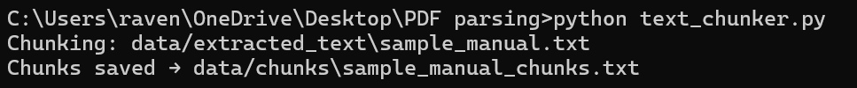
Figure 1: Testing in CMD
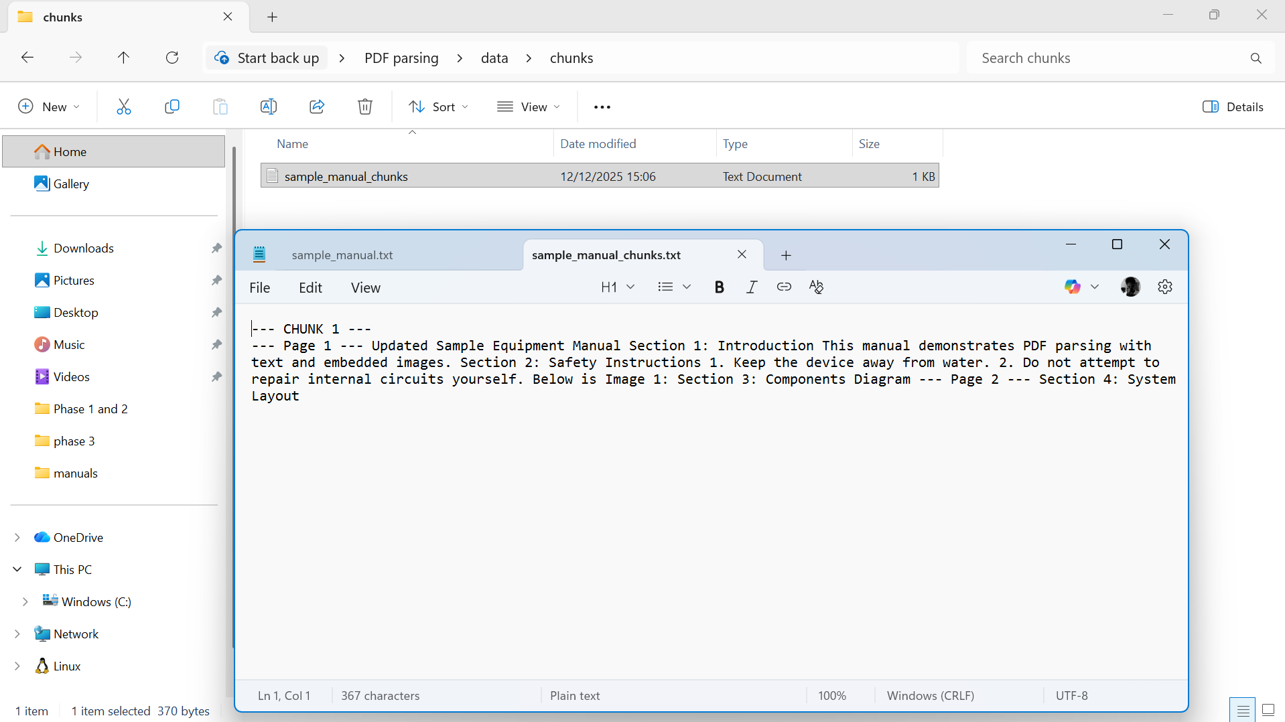
Figure 2: Sample Manual Chunks
Using PyMuPDF, I have developed a PDF parser. Each page’s text and photos were extracted by the parser and stored separately, along with metadata like the page number and image dimensions. For digitally generated PDFs, text extraction performs rather well. Nevertheless, the output from scanned PDFs was noisy. Although several schematics are rotated or of low quality, the image was accurate. To handle scanned PDFs by adding OCR functionality, a few further steps are needed.
Summary
Chunking makes it easier to organise, embed, and retrieve huge PDF documents by breaking it up into shorter, more manageable chunks. A smooth, dependable pipeline for creating embeddings is ensured, vector search speed is increased, and RAG performance is strengthened by using the proper chunking method.

